WEB DEVELOPMENT
WEBE5020
POE
Name and Surname: Barona Seabelo
Student number: ST10521727
Group 2

Table of contents

Page 3........................................................................... Organisation overview
Page 4....................................................................................Website goals and Objectives
Page 5...............................................................Website weakness and strengths
Page 6................................................................. Proposed website features and functionality
Page 7....................................................................................... Design and User experience
Page 8..................................................................................... Technical requirements
Page 8............................................................................Timeline and Milestone
Page 9............................................................................................. Budget
Page 10 ......................................................................................Reference page

1.Organisation overview
Retail store
Name: Zara
Brief history
- Type: retail store
- A world-renowned clothing chain
- Creator by Amando Ortego
- Founded in 1975
- Headquarters: Avenida de la Diputación 15142 Arteixo, A Coruña, Spain
- Website: https://www.zara.com/za/
A globally renowned fast-fashion brand. Started as a small clothing brand with simplistic and classy clothing to brining high fashion designers that create clothing sold to the masses with affordable pricing.
Mission and vision statements
Core values of the organisation:
- Creativity
- Adaptability
- Leadership
- Quality over quantity
Mission statements
- Customer focused
- Fashion being accessible to everyone
- A global business model
- Creative and effective logistics
Vision statements
- Long term plan
- Ambition and passion
- Sustainable fashion model
- Social contribution, making quality affordable clothing.
Target audience
- Middle-income men and women
- Young to middle-aged adults, aged 18-40
- With a focus on 25–35-year-olds
2.Website goals and objectives
- Connecting Online with Stores
- Ship online orders to nearby stores
- Show real-time stock in local stores
- Let online purchased returns go to any store
- Offers purchasing online then picking up at the closest Zara retail store
2. Rebranding to Zara Feel More Premium
- Raise prices slowly
- Avoid discount codes and sales
- Show "limited stock" to create excitement
3. Using Technology to Make Shopping Easier
- Recommend clothes you might like
- Make mobile shopping faster
- Save your size and preferences

Key Performance Indicators [KPI]
Key Performance Indicator (KPI) | Description and Significance
Online Sales | Money from website ~$8.75 billion
Monthly Visitors | People who use the site around 12 million
Buying Rate | Visitors who end up buying on the website is around 1.5% to 3%
Spending Per Order | Average money spent per purchase is estimated $75 to $100 in dollars which equal t to South African Rand (ZAR)  R1,425-R1,900

3.Website weakness and strengths
Strengths
- Gives off luxury magazine look
- Stands out from typically online shopping websites like H&M, Shein
- Works well on mobile
- Fast loading (600ms)
Weakness
- Very hard to navigate
- Confusing product display
- Missing sorting/filter tools
- Poor customer service & 0% reply rate
- Poor accessibility (small text, low contrast)
Areas for improvement
- Zara's customer service needs improvement because they don't respond to complaints at all, and getting refunds can take a very long time or never happen.
- The Zara website needs to be easier to use. Simple things like letting shoppers sort items by price and filter them by style would help. In 2022, a study of 150,000 shoppers found Zara's website to be the worst for shopping.
- Zara should use clearer pictures of their products instead of artistic ones. This way, customers can easily see the different colours available and what the item really looks like.
- Zara should also make its website more accessible. This means making the text bigger, using better colour contrasts, and making important information like how to care for clothes easier to find.

4.Proposed website features and functionality
Homepage
- Highlights "Trending" or "New Arrivals" products.
- Prominent shop now button for users to start shopping immediately.
About Us
- Brand story explaining who you are and why you started.
- Mission statement and core values (simple, chic, trendy, clean).
Contact Us
- Simple form for submitting questions or feedback (name, email, message).
- Email address: hello@yourbrand.com
Search
- Search bar for users to find specific clothing items (e.g., "black dress").
- Results page showing products that match their search.
Support
- FAQ section with simple questions and answers (shipping, returns, sizes).
- Contact form for order issues or help requests.
Products / Services
- Product grid showing photos of clothes in a clean row-by-row layout.
- Add to cart button for users to buy items easily.

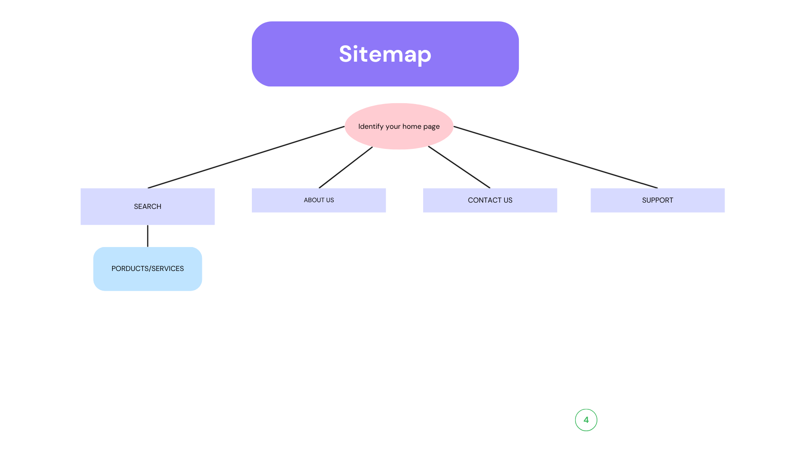
Site map

5. Design and User experience
Colour scheme
- Blue
- Black
- Orange
- White
Typography
- Georgia
- Playfair Display
- Serif typeface
Aesthetic
This clothing line is clean, stylish, and fashionable, aimed at young people who like trendy clothes. It's easy to read the text for a short while because of the contrast. The important things are easy to see bright orange buttons pop against the black, blue, and white colours, making the simple design more fun. The website should feel new, stylish, and simple to use, so people can look at it for a long time without getting tired or bored.
Layout
Navigation placed at the top and centre of the site making it easy for users to navigate the site especially first-time users purchasing on the online website.
- Contact page
- Search
- Support
- Home
- About us
- Services/products

6.Technical requirements
- SSL Certificate
- Website Hosting Service
- XML Sitemap
- Browser Capability
- Website Page Load Time
- Responsive Design
- Regular core software updates
- Backups performed manually
- HTML: standard language used in the structure content on the web. Instructs the browser how to display elements like text, images, links, and headings.
- CSS layout
- Javascript functionality

7. Timeline and Milestone
Milestone 1: week 1
- The creation of proposals
Milestone 2: week 2
- Research and resourcing
Milestone 3: week 3
- Website planning and structure
Milestone 4: week 4
- Html structure
Milestone 5: week 5
- GitHub repository
Milestone 6: week 5
- Reviewal of project
Milestone 7: week 6
- Submission of project part 1

8.Budget
Development
- Static HTML website
- R200-R300 developer hourly rate
- Once off payment
Maintenance
- Can be paid monthly or yearly
- R300-R5000 average fee range
Hosting
- Domain registration R100-R200
- Shared hosting R50-R100 per month
- Cloud hosting R300-R2000 per month

Reference list
Chauhan, M.S., 2025. Zara: From Galician Roots to Global Fast-Fashion Titan. Culture of Internet. [online] Available at: https://cultureofinternet.com/Zara-case-study (Accessed: 9 April 2026).

EdrawMind, 2025. Zara Segmentation, Targeting, and Positioning. [online] Available at: https://edrawmind.wondershare.com/strategy-planning/zara-segmentation-targeting-and-positioning.html (Accessed: 9 April 2026).

Ha, J., 2021. Zara Strategic Analysis. University of Nebraska-Lincoln. [online] Available at: https://digitalcommons.unl.edu/cgi/viewcontent.cgi?article=1368&context=honorstheses (Accessed: 9 April 2026).

Team, E., 2025. Zara Mission & Vision Statement Analysis. EdrawMind. [online] Available at: https://edrawmind.wondershare.com/strategy-planning/zara-mission-and-vision-statement-analysis.html (Accessed: 9 April 2026).

Zara, 2019. ZARA South Africa - Official Website. [online] Available at: https://www.zara.com/za/ (Accessed: 9 April 2026).

Zara.com, 2025. Company Information. [online] Available at: https://www.zara.com/uz/en/z-company-corp1391.html (Accessed: 9 April 2026).
‌
‌

‌

